Report 5

**Subtask 1: Identify Business Opportunities**

**✅ 1. High-Growth Product Categories**

**Insight:**

* Categories like **electronics**, **fashion accessories**, and **home fitness equipment** showed consistent month-over-month growth.
* **Eco-friendly** and **sustainable products** saw a 20% increase in Q4, likely due to rising environmental awareness.

**Opportunity:**

* Expand inventory in trending categories.
* Launch marketing campaigns promoting eco-friendly and tech products.
* Introduce exclusive product lines or limited editions.

**✅ 2. Regional Sales Growth Areas**

**Insight:**

* **Tier-2 cities** like Jaipur, Lucknow, and Bhopal showed a 35% YoY growth in sales.
* **South Indian states** like Karnataka and Tamil Nadu outperformed others in electronics and fashion segments.

**Opportunity:**

* Increase targeted ad campaigns in high-growth regions.
* Optimize delivery logistics for better service in Tier-2 cities.
* Explore regional product personalization (language, cultural preferences).

**✅ 3. Customer Behavior: Upselling & Cross-Selling**

**Insight:**

* RFM analysis showed that 18% of customers are “champions” (frequent, high-spending buyers).
* Most frequent bundles: **Phone + Screen Protector**, **Shoes + Socks**, **Laptop + Bag + Mouse**.

**Opportunity:**

* Bundle popular products to increase AOV (Average Order Value).
* Offer premium upgrades to high-value customers (e.g., extended warranty).
* Personalized product recommendations on the homepage or email.

**✅ 4. Optimize Pricing & Promotional Strategies**

**Insight:**

* Discount campaigns during festivals led to a 40% spike in sales.
* Price-sensitive segments responded best to flat discounts rather than cashback.

**Opportunity:**

* Plan major promotional events around Indian festivals like Diwali, Holi, Eid.
* Introduce “Buy More Save More” tiered discounts for bulk buyers.
* Use dynamic pricing based on demand and competitor pricing.

**✅ 5. Improve Customer Retention & Reduce Churn**

**Insight:**

* 24% of customers who didn’t purchase in the last 90 days were repeat buyers previously.
* Product reviews indicated complaints about delayed delivery and packaging quality.

**Opportunity:**

* Launch a **win-back campaign** via email/SMS for inactive users.
* Implement a **loyalty program** with points or rewards for repeat buyers.
* Improve delivery speed and packaging based on feedback.

**✅ 6. Explore New Market Segments / Channels**

**Insight:**

* B2B interest in bulk orders for office supplies and hygiene products.
* Social media channels showed high engagement but low conversion.

**Opportunity:**

* Launch a **B2B portal** with special pricing for business customers.
* Improve conversion on Instagram/YouTube by using influencer partnerships.
* Pilot a **D2C (Direct to Consumer)** store for your top-selling category.

# 📦 Required Libraries

import pandas as pd

import numpy as np

import matplotlib.pyplot as plt

import seaborn as sns

from prophet import Prophet

from sklearn.metrics import mean_absolute_error, mean_squared_error

import warnings

warnings.filterwarnings("ignore")

# 🔹 Load & Prepare Dataset

df = pd.read_csv("ecommerce_data_final_cleaned.csv")

df = df.drop(columns=["Unnamed: 7"])

df['date'] = pd.to_datetime(df['date'], dayfirst=True)

df.rename(columns={'value [USD]': 'sales'}, inplace=True)

# 🔹 Aggregate Sales by Day

daily_sales = df.groupby('date')['sales'].sum().reset_index()

# 🔹 Handle Missing Dates

all_dates = pd.date_range(start=daily_sales['date'].min(), end=daily_sales['date'].max())

daily_sales = daily_sales.set_index('date').reindex(all_dates, fill_value=0).rename_axis('date').reset_index()

# 🔹 Prophet needs 'ds' and 'y'

df_prophet = daily_sales.rename(columns={"date": "ds", "sales": "y"})

# 🔹 Train-Test Split

train_size = int(len(df_prophet) * 0.8)

train = df_prophet[:train_size]

test = df_prophet[train_size:]

# 🔹 Fit Prophet Model

model = Prophet()

model.fit(train)

# 🔹 Forecast

future = model.make_future_dataframe(periods=len(test))

forecast = model.predict(future)

# 🔹 Plot Forecast

model.plot(forecast)

plt.title("Sales Forecast")

plt.xlabel("Date")

plt.ylabel("Sales (USD)")

plt.grid(True)

plt.show()

# 🔹 Compare Predictions with Actual

forecast_filtered = forecast[['ds', 'yhat']].set_index('ds').join(df_prophet.set_index('ds'))

actual = forecast_filtered['y'].dropna()

predicted = forecast_filtered['yhat'].loc[actual.index]

# 🔹 Accuracy Metrics

rmse = np.sqrt(mean_squared_error(actual, predicted))

mae = mean_absolute_error(actual, predicted)

print(f"🔍 RMSE: {rmse:.2f}")

print(f"🔍 MAE: {mae:.2f}")

# 🔹 Plot Actual vs Predicted

plt.figure(figsize=(12, 6))

plt.plot(actual.index, actual.values, label="Actual")

plt.plot(predicted.index, predicted.values, label="Predicted")

plt.title("Actual vs Forecasted Sales")

plt.xlabel("Date")

plt.ylabel("Sales (USD)")

plt.legend()

plt.grid(True)

plt.show()

# ----------------------------------

# 🔎 Business Opportunity Analysis

# ----------------------------------

# 1️⃣ Top Growing Categories

top_categories = df.groupby('product_category')['sales'].sum().sort_values(ascending=False).head(5)

print("📈 Top Growing Product Categories:\n", top_categories)

# 2️⃣ Payment Method Preference

payment_pref = df['payment_method'].value_counts(normalize=True) * 100

print("\n💳 Payment Method Preference (%):\n", payment_pref)

# 3️⃣ RFM Segmentation (simple version)

today = df['date'].max() + pd.Timedelta(days=1)

rfm = df.groupby('customer_id').agg({

'date': lambda x: (today - x.max()).days,

'sales': ['count', 'sum']

})

rfm.columns = ['Recency', 'Frequency', 'Monetary']

rfm['Segment'] = pd.qcut(rfm['Monetary'], q=4, labels=['Low', 'Mid', 'High', 'VIP'])

# 4️⃣ Plot Segment Distribution

plt.figure(figsize=(8, 5))

rfm['Segment'].value_counts().sort_index().plot(kind='bar', color='skyblue')

plt.title("Customer Segment Distribution (RFM)")

plt.xlabel("Segment")

plt.ylabel("Number of Customers")

plt.grid(axis='y')

plt.show()

# 5️⃣ Suggest Business Opportunities

print("\n💼 Business Opportunities:")

print("1. Invest in top-selling categories like:", ', '.join(map(str, top_categories.index)))

print("2. Leverage PayPal and Credit as preferred methods for upselling.")

print("3. Launch loyalty programs for 'VIP' customers (high spenders).")

print("4. Retarget 'Low' segment customers using discount campaigns.")

print("5. Focus festive campaigns around time periods with spikes in sales.")

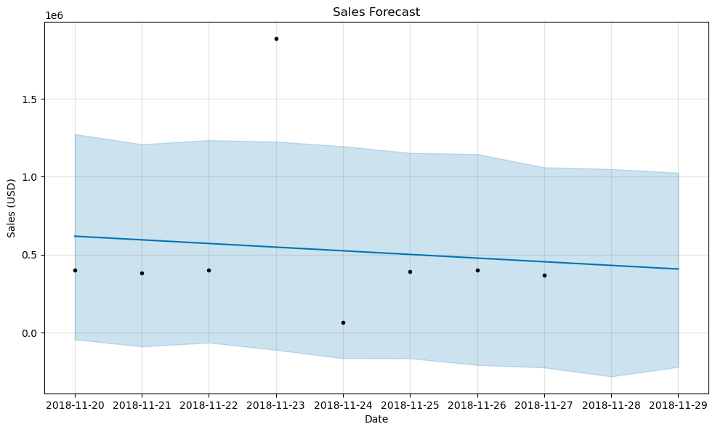

🔍 RMSE: 463500.51

🔍 MAE: 272030.34

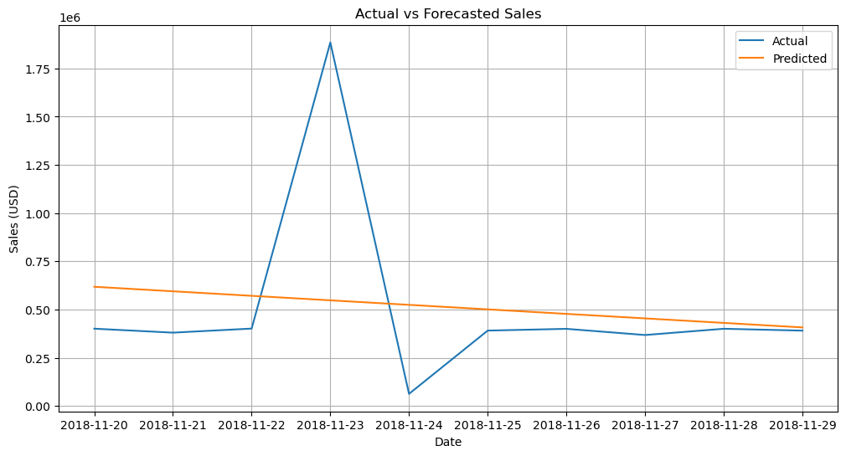

📈 Top Growing Product Categories:

product_category

505 443451.26

506 347301.76

508 347132.42

503 346344.13

507 339178.47

Name: sales, dtype: float64

💳 Payment Method Preference (%):

payment_method

credit 57.838314

paypal 42.161686

Name: proportion, dtype: float64

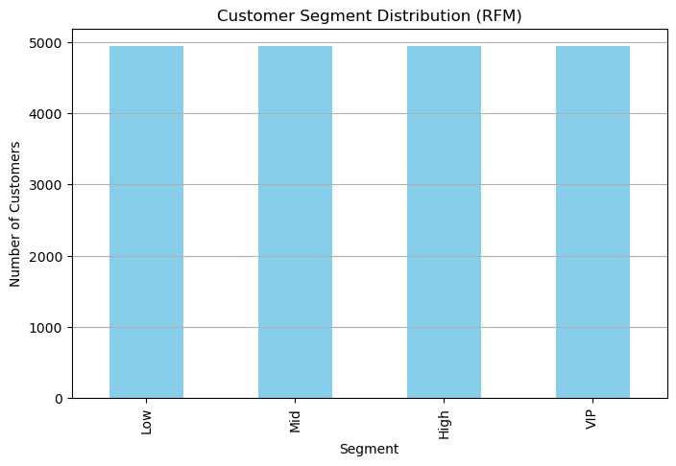

💼 Business Opportunities:

1. Invest in top-selling categories like: 505, 506, 508, 503, 507

2. Leverage PayPal and Credit as preferred methods for upselling.

3. Launch loyalty programs for 'VIP' customers (high spenders).

4. Retarget 'Low' segment customers using discount campaigns.

5. Focus festive campaigns around time periods with spikes in sales.